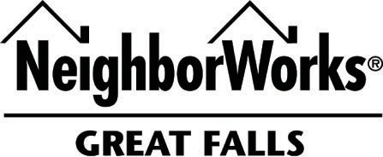

509 First Avenue South, Great Falls, MT 59401 – (406) 761.5861 – www.nwgf.org

Low-Mod Amortizing Second

Eligibility | - Owner-occupied single-family residences only include manufactured homes on a permanent foundation, Condo, Townhome, PUD, Duplex, ADU.  - Borrowers are required to complete a NeighborWorks Great Falls approved homebuyer education class prior to loan closing.  - Great Falls and Cascade County only  - Borrowers must occupy the home as their principal residence for the duration of the loan
Program Summary | - Amortizing subordinate mortgage to assist qualified borrowers with closing costs associated with purchasing a single-family home.  - Borrowers Income must be at or below 150% of the HUD median income guidelines are adjusted for family size and for the county the home is located within.  - For FHA 1st Mortgages the maximum Borrowers Family Income is 115% of the County Median.
Loan Amount | - Minimum loan amount: $2,500  - Maximum loan amount: $20,000
Term | - 30-year fixed rate
Purchase Price | - Limits only as defined by first mortgage
First Mortgage | - Borrower must qualify for a 1st mortgage (FHA/VA/RD/CONV) through an eligible lender.  - First mortgage must be 30-year fixed rate
Interest Rate | - 1.00% below first mortgage rate not to go below 2.00%  - Additional .5% rate cut for preferred partners
Fees | - Loan origination fee of $425.  - Approx $425 in other loan fees (i.e., pre-paid interest, title/closing fees, recording, and post purchase)  - Fees are financed into the NWGF loan up to the maximum loan amount and CLTV
Credit Guidelines | - Housing ratio 32% - Debt to income less than or equal to 42%  - No minimum credit score, but must have approval/eligible finding from first mortgage  - Employment history of 2 years  - Non-occupying co-borrowers not permitted.  - Reserves as required by 1st mortgage
Loan to Value | - CLTV 105%
Borrower investment | - FHA borrowers must contribute required 3.5% down.  - Borrowers are required to contribute 1% of purchase price with a minimum of $1,000 of their own funds.  More than $1,000 may be needed to comply with the 105% CLTV maximum.
Asset Limits | - Total household liquid assets cannot exceed $15,000 and total household assets cannot exceed.  $100,000.00.
Security | - Secured by a Deed of Trust  - NWGF to be in 2nd lien position.  - Mortgage is not assumable.
Payments | - ACH payments are required

