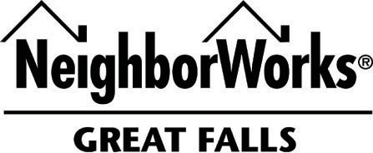

509 First Avenue South, Great Falls, MT 59401 – (406) 761.5861 – www.nwgf.org

NWGF Home Improvement Loans

Eligibility | - Possibly unable to obtain financing through a local lender
Program Summary | - Emergency loans, home equity loans, upgrades or maintenance for your home. There is a lot of flexibility with this program.  - Homeowners request 2-3 bids for scope of work  - Requests over $7,500 reviewed by the Homeownership Center Committee
Loan Amount | - Based upon affordability  - 10% contingency required
Fee | - Loan origination fee of 1% of loan amount.  - Approx $525 in other loan fees (i.e., pre-paid interest, title/closing fees, recording, and post purchase)  - Fees are financed into the NWGF loan up to the maximum loan amount and CLTV
Term | - Based upon affordability and loan amount. Max Term 15 years.
Interest Rate | - At this time, 8%-12%, based upon affordability and risk.
Ratios | - Based upon affordability, 41-45%
Loan to Value | - CLTV 115%
Project Feasibility | - Lending Director evaluates the “scope of work” and bids involved.
Security | - Secured by a Deed of Trust over $3,500 or required by the committee
Scope of Work | - Lending Director with the construction manager monitors the work progress and submits the payment requests.
Payments | - ACH payments are required

