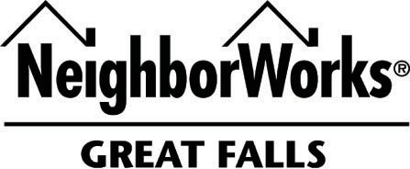

509 First Avenue South, Great Falls, MT 59401 – (406) 761.5861 – www.nwgf.org

Keys to Stability Debt Consolidation Loan

Eligibility | - Borrowers are required to complete a NeighborWorks Great Falls financial counseling session prior to loan closing.  - The borrower must demonstrate a need or desire to purchase a home to qualify for this consolidation loan.  - Borrowers who currently own a home will be required to place a second Deed of Trust (DOT) on their property.
Program Summary | - This loan supports future homebuyers working to strengthen credit or reduce debt on their path to homeownership, and it can also assist current homeowners in better affording their mortgage by consolidating smaller debts. Applicants must provide a valid letter of explanation outlining the hardship and the steps they have taken toward long-term financial stability.
Loan Amount | - Maximum loan amount: $10,000 Minimum loan amount: $1000; May consider higher with 2nd DOT.
Term | - 36 months
Interest Rate | - 8-12% depending on credit score
Fees | - Loan origination fee of $500.  - Fees are financed into the NWGF loan up to the maximum loan amount and CLTV
Credit Guidelines | - Employment history of 6+ continuous months  - 640 and below will have interest rate of 12%  - 640 and above will have interest rate of 8.00%
Asset Limits | - Total household liquid assets cannot exceed $15,000 and total household assets cannot exceed.  $100,000.00.
Security | - Unsecured with the options to secure with DOT on current home, if applicable.
Payments | - ACH payments are required

